INTELLIGENT AGENTS REPORT
Title: Intelligent Agent Design for Autonomous Navigation
Student Name: Rojan Poudel

Contents
1. Introduction 2
2. Agent Design 2
3. Environment and Interaction 3
4. Analysis 5
5. Conclusion 6

Figure 1 : Intelligent Agent Architecture (Perception–Action Model) 3
Figure 2: Autonomous Vehicle Operating Environment with Sensors and Dynamic Elements 4
Figure 3 : Agent–Environment Interaction Cycle 5

1. Introduction
An intelligent agent is an entity with the capability to perceive its surroundings, process information and take action. It is commonly employed in the computer science field to perform operations that require solving complicated tasks which may include uncertainty, changes and real-time situations. One of the most relevant applications of intelligent agents lies within autonomous navigation. It refers to the ability of a device (mostly a vehicle) to move without human interaction while maintaining high standards of performance, reliability and safety, as well as following road traffic regulations.
There are many challenges in this field, including dynamic environment, uncertainty and partial information, unpredictability of human behavior and stringent time constraints for making decisions. Traditional approaches using algorithms and predetermined rules are frequently insufficient to cope with those problems, as they do not allow the device to analyze the current situation and predict the outcome in advance. In contrast, intelligent agents have the potential to continually monitor their surroundings, analyze available data, anticipate different possibilities and act in accordance with the prediction.
In the case of autonomous navigation, intelligent agents serve an extremely important purpose because without intelligent agents, vehicles are not capable of perceiving any obstacles, interpreting road situations, planning routes, and handling unpredictable situations such as abrupt braking and pedestrian activity. Thus, intelligent agents are crucial elements when considering the enhancement of road safety, the minimization of human error, and transportation efficiency. Furthermore, autonomous navigation is gaining much attention from researchers because of its revolutionary influence on various areas such as public transportation, logistics, emergency services, and personal transportation. Autonomous navigation also allows creating smarter cities by implementing intelligent navigation systems in different transport modes. It goes without saying that the importance of developing reliable intelligent navigation systems is rapidly growing along with technological advances.

2. Agent Design
The intelligent agent proposed as a means of enabling autonomous driving is a utility-based one since the chosen type of architecture is well suited for solving complex decision-making problems. In contrast to simple reflex agents that base their reactions solely on inputs and goal-based agents that concentrate exclusively on reaching a goal regardless of possible negative consequences, the utility-based approach considers multiple alternative actions and selects the action that results in the optimal scenario for all the involved parties. Thus, decisions in relation to autonomous driving require considering various factors that include the safety, speed, convenience, and efficiency of the driverless vehicle.
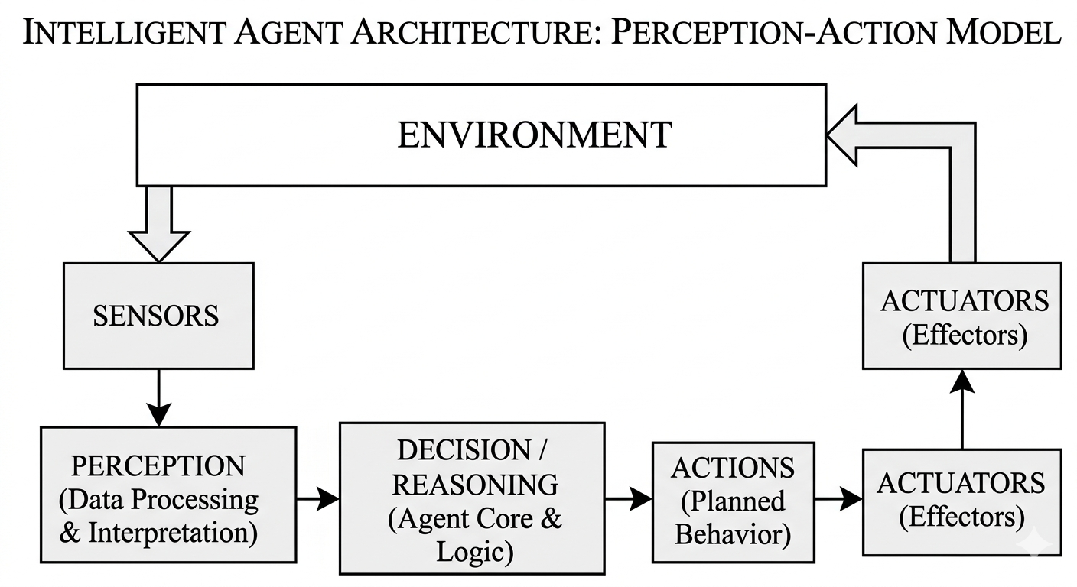
Figure 1 : Intelligent Agent Architecture (Perception–Action Model)
As shown in Figure 1, the architecture of the intelligent agent proposed to operate during autonomous driving includes multiple components of the system. First of all, it includes the sensor component that comprises the necessary equipment. Cameras, radar, LIDAR, and GPS can be used to collect the required data regarding the environment and its current conditions. The second component is the perception one that uses the input data from the sensors to generate information about objects in the environment of the vehicle, lanes and other markings, and traffic lights and signs.
Internal state representation is another element of the architecture of the intelligent agent that helps the vehicle to know about the current state of both the vehicle itself and the objects in its vicinity. Such a state usually includes the position, speed, and direction of movement. The fifth part of the intelligent agent is the decision-making component which evaluates various alternative actions using a utility function. The last one is the actuator component that controls the execution of the selected actions through the process of controlling acceleration, deceleration, and steering.
Decision-making in relation to the agent involves a variety of methods and strategies. The rule-based reasoning method is used to follow traffic regulations in the process of autonomous driving, i.e., to stop at red light or maintain an adequate distance between the vehicle and the other road users. Algorithms like A* can be applied in order to find the shortest way to a destination point. Finally, the decision-making process requires a probability-based evaluation of possible actions to handle the problem of predicting the intentions of other people.

3. Environment and Interaction
Environmental properties of the autonomous navigation intelligent agent can be viewed through several different angles depending on their importance. First, it is necessary to highlight the partial observability of the environment since the agent lacks a complete understanding of the processes occurring in it. Specifically, the limitations of sensors can occur due to weather, visibility, road obstacles or occlusions of one vehicle by another. Thus, an agent has to work with partial or incomplete data. Moreover, the environment in question is dynamic in the sense that it undergoes constant changes due to the movement of other vehicles, pedestrians, cyclists, traffic light changes and others.
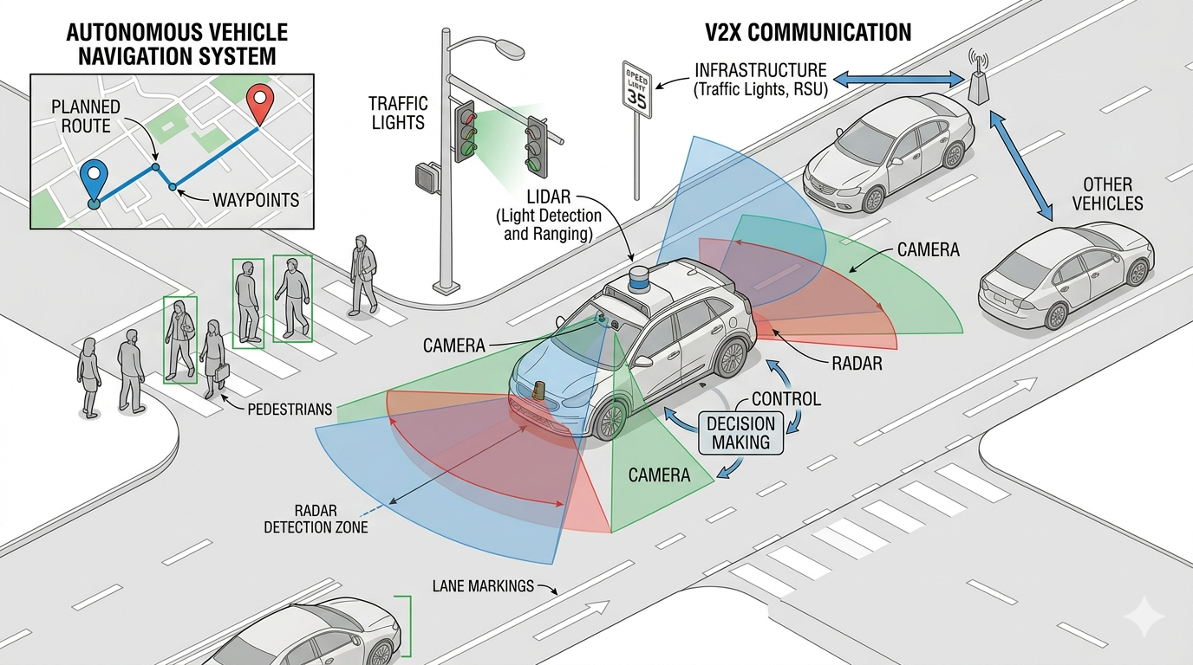
Figure 2: Autonomous Vehicle Operating Environment with Sensors and Dynamic Elements
Figure 2 represents an example of the autonomous driving environment in which the intelligent agent is interacting with dynamic environment entities, including pedestrians, traffic signals, other cars and inputs from such sensors as cameras, radar and LIDAR. Another important characteristic of the discussed environment is its stochasticity because outcomes of actions and observations cannot be predicted with certainty. Specifically, there is always some unpredictability concerning the behavior of the human driver or pedestrian, which makes it impossible to define how exactly their actions influence the environment. Furthermore, the environment is sequential because the results of certain actions depend on the outcomes of previous actions taken. For example, such decisions as too late braking, premature acceleration or lane change at the wrong moment may increase the number of risks in the following stages of driving.
Another property of the discussed environment that needs to be analyzed is its continuity. In this case, the parameters like speed, distance, position and time change continuously without abrupt shifts. Therefore, an agent should be ready to conduct continuous monitoring and adjust the course of its actions to suit the current status of the environment. The process of interaction between the environment and an intelligent agent includes an endless feedback loop. First, an intelligent agent collects information from the environment using its sensors. Further, the data obtained is processed in the perception block. On the basis of the results of this operation, the agent chooses the best action for its particular circumstances. Then the cycle begins again as new observations are made.
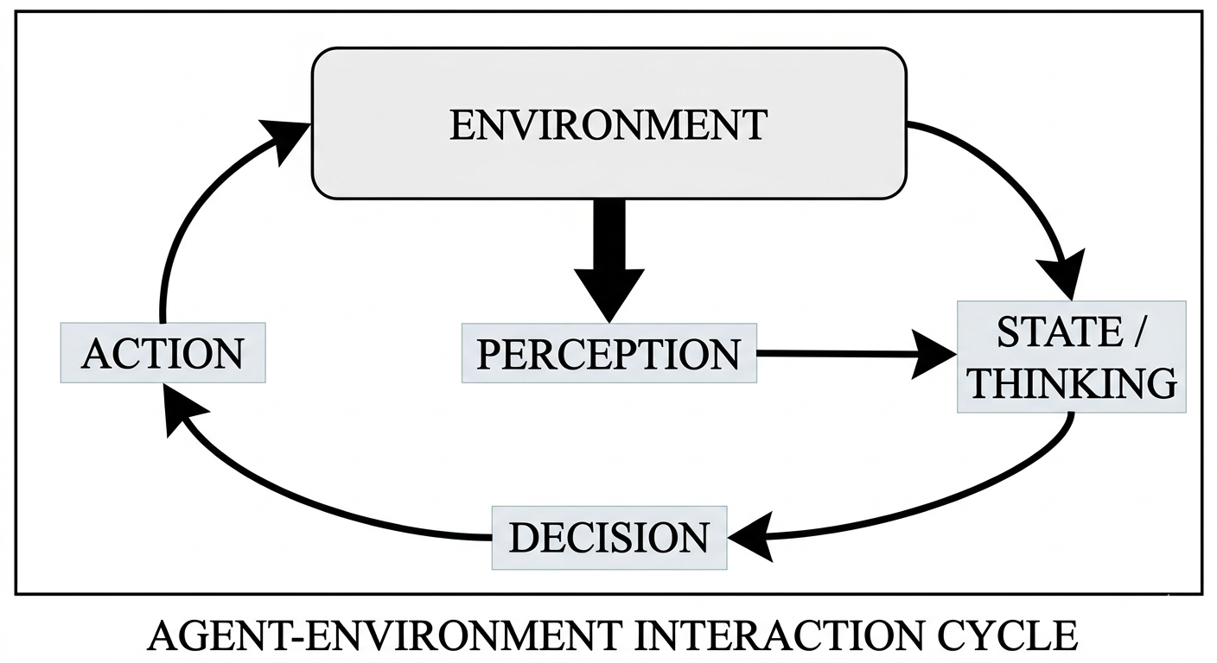
Figure 3 : Agent–Environment Interaction Cycle

4. Analysis
There are many strengths associated with the proposed agent design. For instance, the adaptability is one of its major benefits since the designed intelligent system can adapt to unpredictable changes in the surrounding world. Furthermore, the utility-based method enables the agent to balance between the competing priorities, such as efficiency and safety. The modularity of the architecture makes development and maintenance processes more efficient.
Still, the design is not without weaknesses. The high cost of computation stands out as one of the biggest concerns associated with the proposed intelligent agent. As mentioned above, an ability to process a lot of information in real time is needed. Moreover, the accuracy of the data provided by the sensors plays a crucial role in making accurate predictions about future obstacles. Finally, the system is quite complex, which poses challenges for thorough testing, especially when talking about edge cases.
In terms of time complexity, the worst case scenario for A* is O(b^d), where b is the branching factor and d is the depth of the solution path. In other words, the amount of possibilities in the path finding algorithm depends greatly on both these factors and grows quite significantly in complicated situations. What is more, the space complexity of the designed system can be quite high due to the maps that should be used, along with various other parameters.
Finally, there are a lot of things that can be done to improve the agent's performance. For example, machine learning techniques can be used to enhance the perception of its surroundings. In turn, this will positively affect its decision-making process and enable the system to learn from its previous experiences. The sensor data can be merged to increase reliability. Real-time optimization techniques can be utilized to lower the computational cost.

5. Conclusion
Therefore, intelligent agents represent an excellent tool for solving the problem of autonomous navigation, which is among the most difficult and promising applications in the field of artificial intelligence. In particular, autonomous navigation involves making decisions in real-time based on incomplete information in complex, uncertain, and potentially dangerous settings. As a result, it perfectly matches the principles of intelligent agents. In particular, the suggested architecture of utility-based agents enables evaluating various options for behavior and balancing several essential goals, including safety, economy, passenger comfort, and compliance with traffic rules. The examination of the environment and the process of interaction indicates that autonomous driving heavily relies on consistent sensing, feedback, and adaptation.
Moreover, the review of the properties of the proposed intelligent agent reveals that while it possesses numerous benefits, including flexibility, structured inference, and goal-directedness, it still suffers from some deficiencies, such as computational complexity, reliance on reliable sensing devices, and poor management of exceptional situations. Possible improvements may involve incorporating machine learning algorithms, enhancing sensors' capacity for fusion, and employing hybrid approaches to decision-making. Consequently, intelligent agents possess enormous potential to revolutionize transportation systems, increasing their safety, intelligence, and efficiency. Nevertheless, to be implemented successfully, intelligent agents must undergo extensive research and design.

